***Kaleidoscope***

**Box 506**

**Andover, MA 01810**

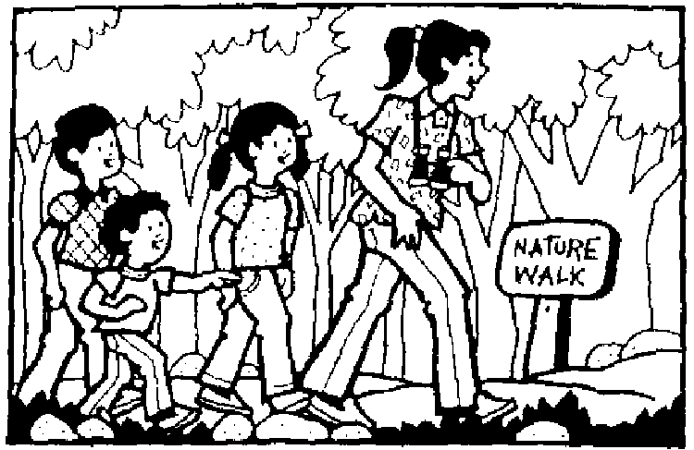Dear Parents,

Your child is going to experience a high energy week in Adventures In Science. The schedule included with this letter indicates that we will explore a new environment filled with the mysteries of nature each day. Time spent in in the classroom will be devoted to discussions, books, or projects that further enhance our experiences. The classroom itself will also be a living environment of in-house creatures and natural artifacts.

Please help us to make this a wonderful experience for your child by remembering the following things:

1) Please provide a lunch and drink (and snacks) every day for your child, as this is a full-day

course.

2) Please dress your child appropriately according to the weather and special instructions on the daily schedule.

3) Please let us know in writing about any allergies your child may have to certain foods or insect bites or whether he or she is highly susceptible to poison ivy. Check for ticks, particularly on legs and hair, upon your child’s return.

4) Please apply insect repellent and sunblock before your child leaves for the day. (Recommended each day.)

5) Children will benefit from an early bedtime so they can deal physically with the activity level of the course.

6) If you have any questions, please feel free to email me anytime at christa.ritter17@gmail.com.

I'm very excited about sharing my enthusiasm for nature with your child!

Till then,

Christa Ritter

(CONTINUED)

ADVENTURES IN SCIENCE

PLEASE NOTE: All classes meet from 9:00 – 2:30 PM

# MONDAY, JULY 8

Meet the classroom personnel.

Exploration of the area behind Pike School. We will engage in scientific investigations and conduct a mini beast search. Dress children in sneakers, hat, pants or shorts, and high socks.

# TUESDAY, JULY 9

# Trip to Wingaersheek Beach in Gloucester, MA. We will be exploring tidal pools in the rock areas of the beach. Children should wear old sneakers or good climbing shoes(that can get wet!) as the rocks have much barnacle growth on them. Sandals are not appropriate or safe. Please provide a complete change of clothing as well as a second pair of shoes and socks. It helps to pack a plastic bag to transport the wet, sandy clothes and shoes home. Also, please provide a towel, sweatshirt, hat, sunblock, a collecting bucket, and extra drinks. All articles should be labeled with the child’s name. Due to the length of the ride on this trip, children may bring a small game or toy along if desired. Trip departs at 9:00 AM and returns at approximately 2:00 PM.

# 

**WEDNESDAY, JULY 10**

Trip to Ward Reservation in Andover. Children will follow the boardwalk to discover a quaking bog. Afterwards, we will hike up Holt Hill to visit the solstice stones and view the Boston skyline. Dress children in sneakers, hat, pants or shorts, and high socks. Trip departs at 10:30 and returns at 1:00.

## THURSDAY, JULY 11

Exploration of the pond at Great Brook Farm State Park in Carlisle. Children will be provided with strainers for dipping to discover the dense population of mini creatures that inhabit the environment of the pond. We will also try our hand at stalking frogs. Please bring a fishing net if you have one. Trip departs at 9:45 AM and returns at approximately 2:00 PM.

Please dress children in boots or OLD sneakers. Send a towel and a change of shoes and socks with a plastic bag for transporting wet shoes.

We will also visit the local dairy farm on site. Please send your child with $4.50 if they wish to purchase an ice cream.

# FRIDAY, JULY 12

Trip to America’s Stonehenge in Salem, NH. The children will explore this archaeological site and surrounding nature trails. We will also visit with the llamas and find gems in the dig pit. Please dress children in sneakers, hat, pants or shorts, and high socks. Trip departs at 9:45AM and returns at 1:30PM.

_ _ _ _ _ _ _ _ _ _ _ _ _ _ _ _ _ _ _ _ _ _ _ _ _ _ _ _ _ _ _ _ _ _ _ _ _ _ _ _ _ _ _ _ _ _ _ _ _ _ _ _

Please bring this permission form with you on Monday.

I give permission for my child _____________________________ to participate in all of the activities and field trips with the Adventures in Science class of Kaleidoscope 2019. I understand that bus transportation will be provided

__________________________________________________ _________________

(parent’s signature) (date)