MODELS, MOTION & MOMENTUM

Welcome to Models, Motion & Momentum! This week your child will learn about the basic principles of gravity, friction, stored energy and more. We will test and experiment these laws and concepts with Lego bricks. We will use the Lego bricks to build cars, three types of bridges, towers, and even catapults to demonstrate first-hand how these concepts of science truly work!
Get ready for some fun and investigating all while gaining important and useful knowledge about the world around us.
Bring a “can do” attitude as well as be prepared to problem solve and think out of the box upon entering class!
I am very excited and looking forward to taking these concepts and applying them in a kid-friendly and understandable way! So let's get started!

Sincerely,
Molly Dowell
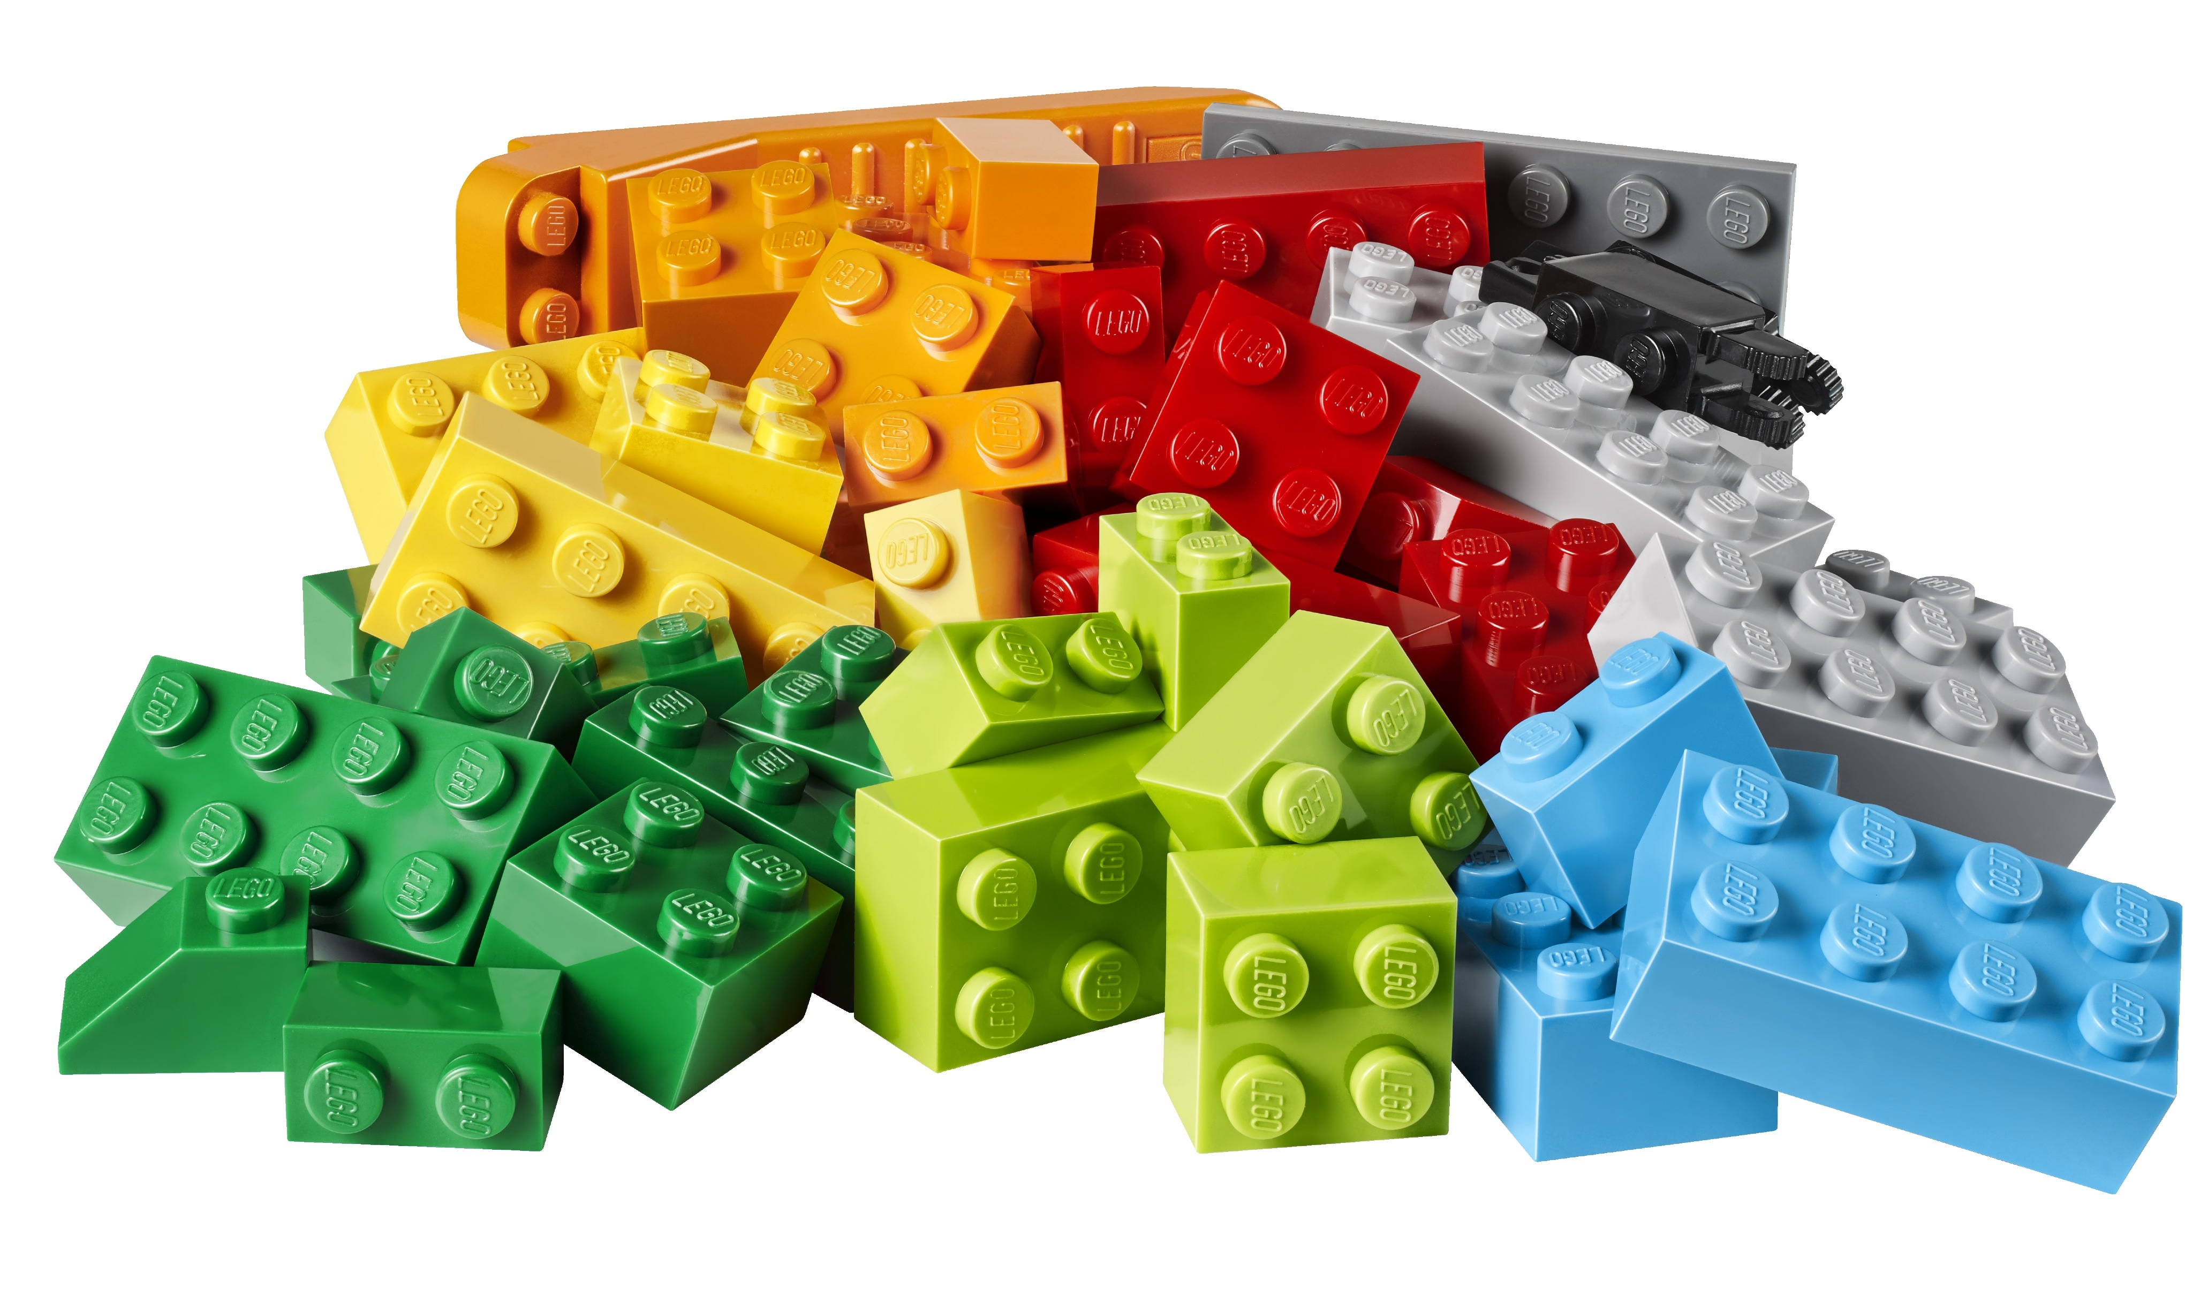
Models, Motion & Momentum Instructor

